Rabee’ ul Awwal
Sunnah Challenge

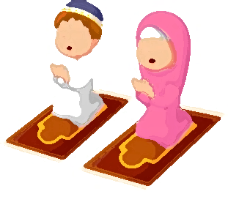
‘I want to walk like you, talk like you, read my Quran just like you, I want to be like you in everything I do, you are the closest to Allah, I want to smile like you, breathe like you, read my salah just like you, I want to be like you in everything I do Ya Rasulullah’

Sunnah | Tally | Total
Dua upon awakening: Alhamdulillahil-ladhi ahyaana ba’da ma amaatana wa ilayhin nushoor
I entered the bathroom with my left foot and read the dua: Allahumma inni audhubika minal khubuthi wal khabaa-ith
I brushed my teeth
I brushed my teeth with miswaak
I made wudhu
I left the bathroom with my right foot and read the dua for leaving the bathroom: Ghufraanak! Alhamdulillahil-ladhi adhaba annil adha wa aafaani
I wore my clothes starting from the right hand side first
I took my clothes off starting from the left hand side first
I read the wearing clothes dua: Alhmadulillahil-ladhi kasaani hadha wa razaqaneehi min ghayri hawlim-minni wa la quwwah
I put oil in my hair
I ate on the dastarkhan
I read the dua before eating: Bismillahi wa ala barakatillah
I did not complain about my food
I ate with my right hand, cleaned my plate and licked my fingers
I read the dua after eating: Alhamdulillahil-ladhi at’amanaa wa saqaana wa ja’alana minal muslimeen
I drank water whilst sitting down and in 3 sips
I read the dua for drinking water: Bismillah
I read Qur’an/Amma/Qa’ida
I prayed Durood 100x today
When wearing my shoes I wore my right shoe first
I read the dua when leaving home: Bismillahi tawakkaltu alallah. La hawla wa la quwwata illa billah
Rabee’ ul Awwal
Sunnah Challenge continued

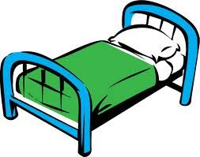
“Say (O, Muhammad): if you love Allah, FOLLOW ME Allah will love you and will forgive your sin Allah is Forgiving and Merciful”
“Whoever revives my Sunnah then he has loved me, and whoever loved me, he shall be with me in Paradise”

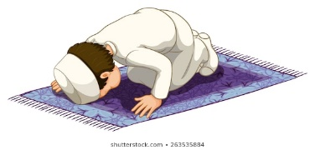

Sunnah | Tally | Total
I read the dua when entering the home: Allahumma inni as’aluka khayral mawlaji wa khayral makhraji. Bismillahi walajna wa bismillahi kharajna wa ala rabbina tawakkalna
I said Assalaamu’Alaikum Wa Rahmatullahi Wa Barakatuh
I made someone smile
I did not hurt anyone’s feelings today
I prayed Ayatul Kursi before bed
I prayed Tasbih Fatimah Subhanallah x33 Alhamdullilah x33 Allahuakbar x34
I read the sleeping duaa: Allahumma bismika amutu wa ahya
I slept on my right hand side
Write extra Sunnahs you do below
Grand Total =
250 points = bronze award | 500 points = silver award | 750 points = gold award | 1000 points = platinum award

